Entity-Relationship Diagram for Small College

Lane Dorscher
01/24/2026
CIS309-T302 Data and Information Management (2263-1)
Jack Li

Business Requirements:
The purpose of this database is to manage and maintain accurate information about colleges, professors, courses, and the assignments of professors to courses. The following business requirements have been identified:
- College Information Management
  - The system must store essential details about colleges, including name, address, city, state, and ZIP code.
  - Each college must have a unique identifier (COLLEGE_ID) to distinguish it from other colleges.
- Professor Information Management
  - The system must maintain a list of all professors associated with each college.
  - Each professor should have a unique identifier (PROFESSOR_ID) and attributes such as name, employment status, and salary.
  - Professors must be linked to the college where they are employed.
- Course Information Management
  - The system must maintain information about courses offered, including course name, course ID, and credits.
  - Each course must have a unique identifier (COURSE_ID) to prevent duplication.
- Class/Teaching Assignment Management
  - The system must track which professor teaches which course.
  - Since a professor can teach multiple courses and a course can be taught by multiple professors, a many-to-many relationship must be captured through an associative entity (Class).
- Data Integrity and Normalization
  - Data must be stored in Third Normal Form (3NF) to reduce redundancy and ensure consistency.
  - All entities must have appropriate primary keys and foreign keys to maintain referential integrity.
- Operational Efficiency
  - The system should enable efficient queries, such as listing all courses taught by a professor, all professors at a college, or all courses offered by a college.
Identified Entities and Attributes
1. College
Stores information about colleges.
- COLLEGE_ID (PK) – Unique identifier for each college
- COLLEGE_NAME – Name of the college
- COLLEGE_ADDRESS – Street address
- COLLEGE_CITY – City where the college is located
- COLLEGE_STATE – State of the college
- COLLEGE_ZIP_CODE – ZIP code
2. Professor
Stores information about professors.
- PROFESSOR_ID (PK) – Unique identifier for each professor
- PROFESSOR_NAME – Full name of the professor
- PROFESSOR_STATUS – Active, on leave, retired, etc.
- PROFESSOR_SALARY – Salary of the professor
- COLLEGE_ID (FK → College.COLLEGE_ID) – College where the professor works
3. Course
Stores information about courses.
- COURSE_ID (PK) – Unique identifier for each course
- COURSE_NAME – Name of the course
- COURSE_CREDITS – Number of credits
4. Class
Represents which professor teaches which course.
- COURSE_ID (FK → Course.COURSE_ID)
- PROFESSOR_ID (FK → Professor.PROFESSOR_ID)

Proposed Relationships
A college can have multiple professors, but a professor belongs to only one college.
A professor can teach multiple courses.
A course can be taught by multiple professors.

Entity Relationship Diagram
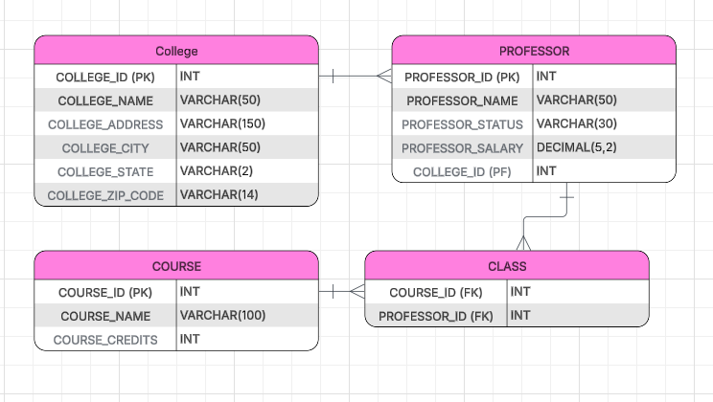
Conclusion
The Crow’s Foot ERD designed from the provided operational data ensures a structured and normalized database that eliminates redundancy and maintains data integrity. By separating Colleges, Professors, and Courses into distinct entities and introducing an associative entity (Class) for teaching assignments, the database supports the complex many-to-many relationships inherent in course assignments while maintaining clarity and scalability. Implementing this ERD in a relational database will allow the college to efficiently manage academic data, generate reports, and support decision-making processes related to faculty, courses, and college operations.

